

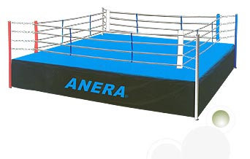
Screen time: __________
Exercise time: _________

Winner of round:
_____________________

Screen time: __________
Exercise time: _________

Winner of round:
_____________________

Screen time: __________
Exercise time: _________

Winner of round:
_____________________

Screen time: __________
Exercise time: _________

Winner of round:
_____________________
Screen time: __________
Exercise time: _________

Winner of round:
_____________________

Screen time: __________
Exercise time: _________

Winner of round:
_____________________
Screen time: __________
Exercise time: _________

Winner of round:
_____________________

Screen time: __________
Exercise time: _________

Winner of round:
_____________________

Did the healthiest opponent win? (Circle your answer) Yes No
Screen time: __________
Exercise time: _________

Winner of round:
_____________________

Directions

See the event of the year: The electrifying Screen-ercise in one corner against Exercise in the other corner. Who is most fit and ready to go? Go 12 rounds (or days) yourself and record how much time you spend exercising versus watching TV, playing video games, or using the computer. Each day, whichever opponent logs the most time wins that round. At the end of 12 rounds, whoever has won the most rounds wins the match. When you complete this sheet pick up another one for 12 more days. Good luck and may the healthiest contestant win!
Screen time: __________
Exercise time: _________

Winner of round:
_____________________

Screen time: __________
Exercise time: _________

Winner of round:
_____________________
Screen time: __________
Exercise time: _________

Winner of round:
_____________________

