Name:
Class/Hour:


Not too fast, not too slow. Look for the wildlife as you go. For every 15 minutes you jog, or 30 minutes you walk, in the park (or at home) color in a section of the boardwalk.
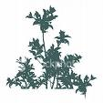







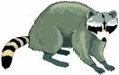

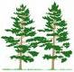

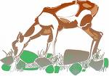



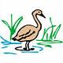


© Steven A. Henkel, 6/08

